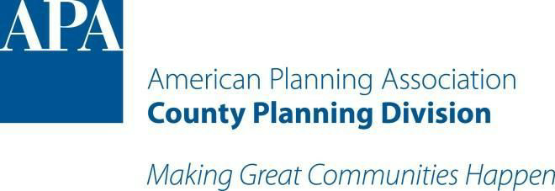

Meeting Notes Summary
APA County Planning Division – Executive Committee Teleconference
March 18, 2020
4:00 PM EST / 3:00 PM CST / 2:00 PM MST / 1:00 PM PST
Dial in Number: 1 (866) 499-7054
Access Code: 7976296547

- Call to Order - Chris acknowledged no quorum at 3:10 pm
- Roll Call
  - Members present - Chris, David, Sam, Lizzy, Royce, and Jack
- Approval of February 2020 Executive Committee Minutes - no quorum present
- Finance Report – Robert Hill, Treasurer
  - Robert Hill was not present for the meeting
- Chair Update - Chris led the discussion on the NPC20 and related topics
  - NPC 20 - Canceled due to COVID-19
    - Annual Meeting – Chris called for discussion on a potential virtual meeting. David brought up an idea to organize some kind of county planner meetup in a centrally located in the US for an annual meeting and/or awards program in lieu of not having the NPC this year. Chris would like to have a board retreat for the executive board members to get together in person to do a strategic plan for CPD and NACP. Jack mentioned that the NACO Annual Conference is July 15-18 in Orange County, Florida (Orlando) and could accommodate a board retreat. David to reach out to Chad Nabity (DC rep for CPD) about Division Annual Meeting and other requirements. David will include Chris in these discussions and action items for the full board. Sam left due to connection issues at 3:19 pm (CT). Chris would like to proceed with organizing a board retreat at the NACO conference.
      - Awards Program - Awards Committee
        - Royce reported for the committee that they have received 4 total applications. Tim will have a report with recommendations of award category winners to Chris soon. Royce explained the awards program for Lizzy (Student Rep) and the 5 award categories for outstanding projects.
    - Division Session Endorsements - canceled
      - Autistic Professionals in the Planning Field - cancelled
      - Embodying Inclusion: World’s Largest Potluck
      - Vision to Action: Foundation for Impact
      - Wetlands: Rural and Urban Water Solutions
    - Joint Reception – Cancelled
    - Student Representative Grant - talked about this last meeting
- Committee Updates
  - Webinar - Tim Brown - none
  - Awards - Tim Brown - none
  - Education/Division Partnership Summary/Newsletter – Alison Tompkins
    - David mentioned that he participated in a tour/presentation of SDSU Landscape Architecture program students as part of the South Dakota Planners Association. One of the instructors, Jeremiah Bergstrom, set up a half day tour/presentation/Q&A with planners from eastern SD. It was a really interesting experience that both the students and us planners learned a lot from each others projects. David will work with Alison to coordinate educational items applicable for students/working professionals to network and learn from each other.
  - Social Media – Michelle Fuson
    - none
  - Student Representative – Sam Hoffman
    - Transition from Ms. Samantha Hoffman to new Student Liaison, Lizzy
    - Lizzy will be the new Student Representative for CPD
    - There was discussion on outreach to student member list. Chris explained that county planning often takes a back seat in planning education and APA affairs. It is important that counties deserve attention at the collegiate level for the various county issues. Lizzy mentioned that students are often thrown off by the work that county planners do in their local co-op program.
- Schedule Next Executive Committee Meeting Date and Time
  - May 20, 2020 – 4:00 PM EST, 3:00 Central, 2:00 Mtn, 1:00 Pacific
- Other Business
  - David mentioned that the new CPD website is live. He told board members to visit county.planning.org to give Chris, Jacqui, and David feedback. We are looking to design the website in a way that maximizes engagement of our members. Chris, Jacqui, and David to regroup on website planning.
- Adjournment - Close meeting at 3:40 pm to transition to NACP meeting

